1. **Introduction**
2. **1 Project Description**

“QUEUE MANAGEMNET SYSTEM” is a standalone application designed as a purpose to negate the traditional approach of Queuing. This application provides an easy and simple way to the administrator to maintain the data of users with all basic operations and generate a token for any one of the card holding member. This application to provides the end users to receive their provision without waiting for a long period of time standing in the queue. The administrator can perform activities like adding, deleting, modifying the data base, generating a queue and executing the queue with a smooth manner. The administrator can view all the details of users.

Login is the beginning stage of project where administrator Logs-in using the provided Login Credentials. The application modules run only if the Login credentials are exact as provided.

1. **2 Problem Statements**

“The main aim for developing the application is to try overcoming the traditional way of Queuing (i.e. Standing in Line for a long period of time to meet their requirements).”

1. **3 Existing System**

The Present Queue Management System generates a token for the users but the main disadvantage is that the users are required to wait unless and until that particular token is called for. So the current system actually makes the end user wait for their turn.

**Drawbacks**

* Wastage of end-users time
* No other works can be planned by end-user

1. **4 Proposed System**

The Proposed System is a unique and simple method adopted to overcome traditional approach using the date and time constraint. Each user is given a token with both current date/time and token expiry date/time. So this technique can reduce the wastage of end-users time by allowing them to carry out their work on or before the time specified in the token.

1. **5 Objectives**

* To overcome traditional Queuing using time delay.
* To provide the end- user with timely access to resource

1. **6 Benefits of the proposed system**

* Processing Speed
* Convenience to Customers
* Results in Smooth functioning of organization
* Satisfaction to Customers.
* Better performance in Customer Flow

**2.System Requirement**

**2.1 Hardware Specification (Minimum)**

Computer Processor : Dual Core

Processor Speed : 2.8 GHz Processor

Hard Disk : 40 GB

RAM : Min 745 MB

Monitor : 14’’ color or black and white

**2.2 Software Specification**

Operating System : Windows 10 Enterprise/XP/Vista/Seven

Front End : Visual Basic 6.0

Back End : SQL

Language Used : Visual Basic

Documentation : Microsoft Office 2013

**2.3 Tools Survey**

**2.3.1 MySQL**

**SQL vs. MySQL**

**SQL** stands for **S**tructured **Q**uery **L**anguage. It’s a standard language for accessing and manipulating databases. MySQL is a database management system, like SQL Server, Oracle, Informix, Postures, etc. MySQL is a RDMS (Relational Database Management System) System.

When considering a utility for data management the two most popular choices are MySQL and SQL Server. Both are efficient at keeping your data organized and readily available through a user interface. Both technologies have the concept of schema (that is table storage) for data storage.

SQL is a language. Specifically, the “Structured Query Language” Now it would be better if we start differentiating the topic as **difference between SQL server and MySQL** and take them point by point.

Now going to differences:

* MYSQL is available for free since it is open source, But SQL is not open source.
* MYSQL offers only updateable views, SQL offers indexed views which are much more powerful, performing wise.
* MYSQL doesn't support XML, Whereas XML supports it.
* Auto tuning is not supported in MYQL, but can in SQL.
* User defined functions are not supported in MYSQL, But supported in SQL.
* Transaction support is very much limited in MYSQL, but extensively and fully offered in SQL.
* Stored procedures and full joins not offered in MYSQL, but offered in SQL.
* Cursor feature is not there in MYSQL but is there in SQL
* Job scheduling and profiling not available in MYSQL, but available is SQL.

**Oracle vs. MySQL**

**Oracle** is the leading database management system released by Oracle Corporation. **MySQL** is a database management system sponsored by a company named MySQL AB. Now, MySQL is also acquired by Oracle Corporation. Compare the major differences between Oracle and MySQL points wise.

**MySQL:**

* MySQL is an open source and MySQL is available for free download and installation.
* User authentication is performed in MySQL by using only location, username and password.
* Flexibility of creating stored procedures and functions using PL/SQL is very less in MySQL.
* MySQL offers very few commands related to generating output as report and defining variables. MySQL includes only very simple SQL commands.
* MySQL does not have the audit vault feature in the server.

**Oracle:**

* Oracle provides audit vault facility.
* Oracle offers tools at enterprise level.
* Oracle provides the row locking facility as well.
* Oracle has a very extensive storage features. Oracle supports tablespace, synonym, packages and all other features.
* Oracle supports and uses XML.

**3.Design Specification**

**3.1 ENTITY RELATIONSHIP DIAGRAM**

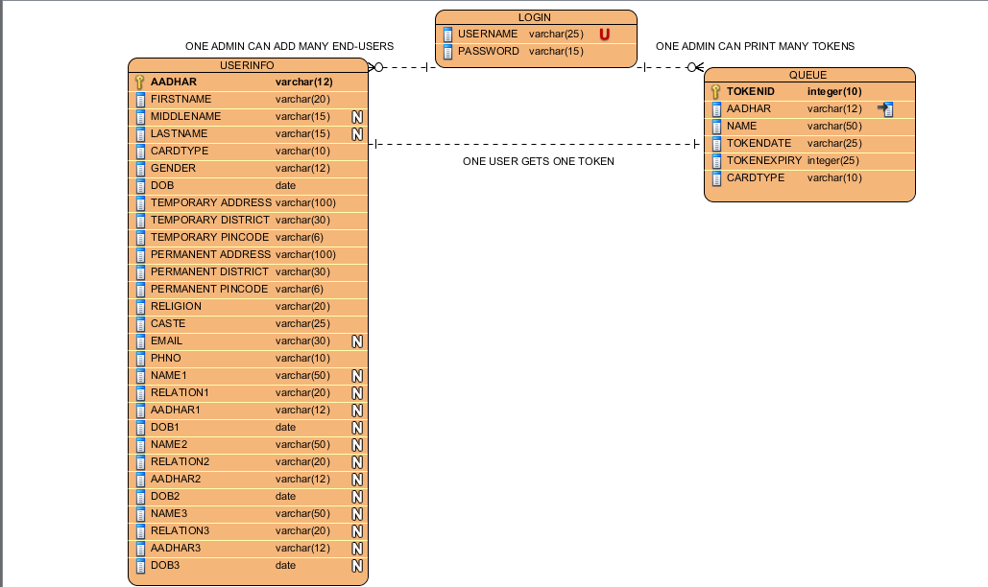

**3.2 DATA FLOW DIAGRAM**

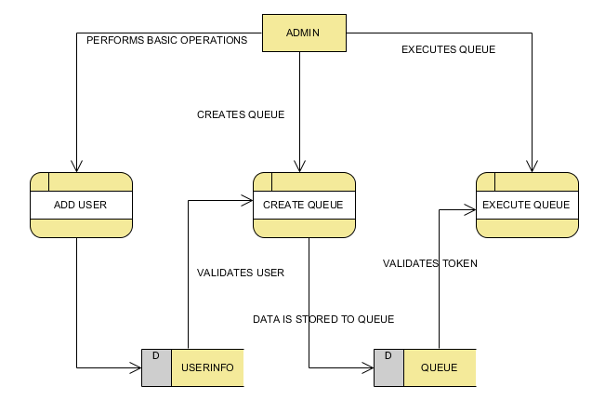

**4.Coding**

**4.1 LOGIN MODULE**

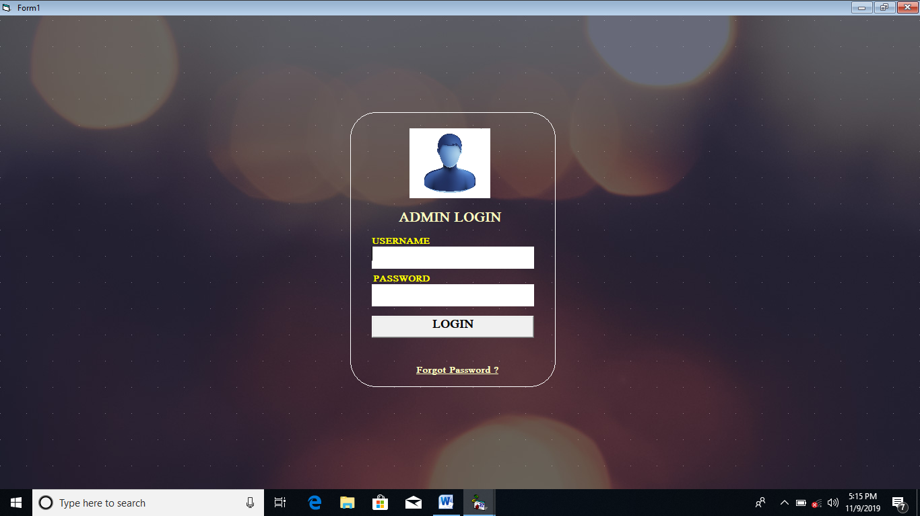

Private Sub cmdlogin_Click()

rs.Open "select *from login", con, adOpenDynamic, adLockPessimistic

rs.MoveFirst

Dim i As Integer

i = 0

While Not rs.EOF = True

If rs.Fields("username").Value = textusername.Text And rs.Fields("password").Value = textpass.Text Then

i = i + 1

Form3.Show

Unload Me

End If

rs.MoveNext

Wend

If i = 0 Then

MsgBox "User Does Not Exist", vbOKOnly, "INVALID"

textusername = ""

textpass = ""

textusername.SetFocus

End If

rs.Close

End Sub

**4.2 PASSWORD CHANGING MODULE**

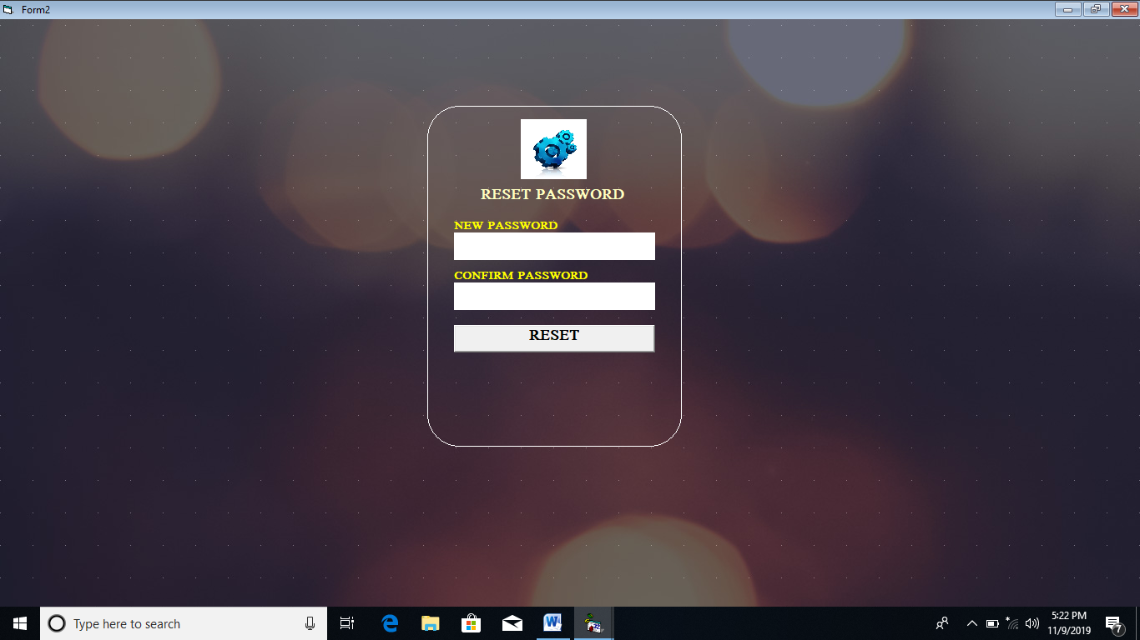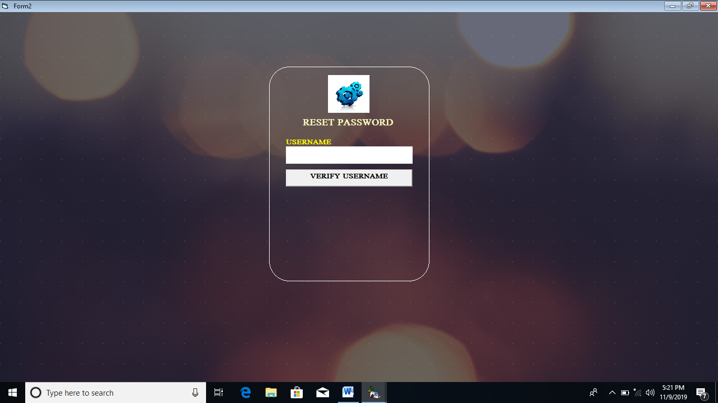

Private Sub cmdverify_Click()

If rs.Fields(0).Value = textusername.Text Then

labelusername.Visible = False

textusername.Visible = False

cmdverify.Visible = False

labelnew.Visible = True

labelnew.Top = 3600

Textnwpass.Visible = True

Textnwpass.Top = 3840

Labelconfirm.Visible = True

Labelconfirm.Top = 4500

textconpass.Visible = True

textconpass.Top = 4740

cmdreset.Visible = True

cmdreset.Top = 5500

Textnwpass.SetFocus

Else

MsgBox "Invalid User", vbOKCancel + vbDefaultButton2 + vbCritical, "User Validation"

textusername = ""

textusername.SetFocus

End If

End Sub

Private Sub Textnwpass_LostFocus()

Dim byt As Byte

Dim aa As Integer

Dim strc As String

If Len(Textnwpass.Text) >= 8 Then

For aa = 1 To Len(Textnwpass.Text)

strc = Mid$(Textnwpass.Text, aa, 1)

If strc >= "!" And strc <= "/" Then

byt = byt Or &H8

End If

If strc >= "0" And strc <= "9" Then

byt = byt Or &H4

End If

If strc >= ":" And strc <= "@" Then

byt = byt Or &H8

End If

If strc >= "A" And strc <= "Z" Then

byt = byt Or &H2

End If

If strc >= "a" And strc <= "z" Then

byt = byt Or &H1

End If

Next aa

End If

If byt <> &HF Then

MsgBox "Password Should Contain atleast one Uppercase Letter,Lowercase Letter,One Number and a Special Character And Must Contain Minimum of 8 Charcters", vbOKOnly + vbInformation, "Password Information"

Textnwpass = ""

Textnwpass.SetFocus

End If

End Sub

Private Sub cmdreset_Click()

If Textnwpass.Text = textconpass.Text Then

rs.Fields(1).Value = textconpass.Text

rs.Update

MsgBox "Password Successfully Updated", vbInformation + vbOKOnly, "Change password"

Form1.Show

Unload Me

Else

MsgBox "Password Not Matched", vbInformation + vbOKOnly, "Change password"

Text1 = ""

Text2 = ""

Text1.SetFocus

End If

End Sub

**4.2 APPLICATION MODULE**

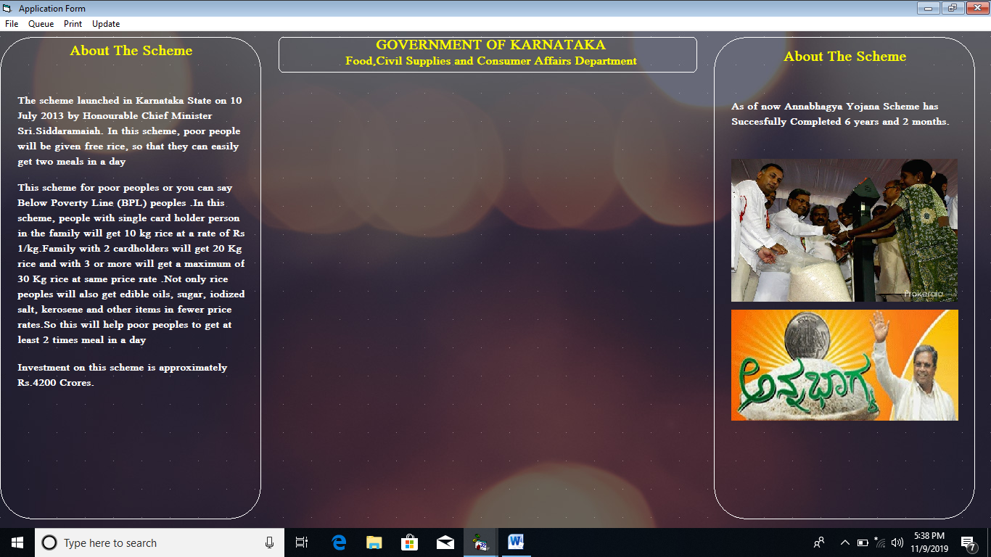

**Private Sub Form_Load()**

WindowState = 2

Label26.Caption = "About The Scheme"

Label21.Caption = "About The Scheme"

Label20.Caption = "The scheme launched in Karnataka State on 10 July 2013 by Honourable Chief Minister Sri.Siddaramaiah. In this scheme, poor people will be given free rice, so that they can easily get two meals in a day"

Label23.Caption = "Investment on this scheme is approximately Rs.4200 Crores."

Label25.Caption = "As of now Annabhagya Yojana Scheme has Succesfully Completed 6 years and 2 months."

Label19.Caption = "This scheme for poor peoples or you can say Below Poverty Line (BPL) peoples .In this scheme, people with single card holder person in the family will get 10 kg rice at a rate of Rs 1/kg.Family with 2 cardholders will get 20 Kg rice and with 3 or more will get a maximum of 30 Kg rice at same price rate .Not only rice peoples will also get edible oils, sugar, iodized salt, kerosene and other items in fewer price rates.So this will help poor peoples to get at least 2 times meal in a day"

con.Open "Provider=MSDASQL.1;Password=root;Persist Security Info=True;User ID=root;Data Source=yogesh"

rs.CursorLocation = adUseClient

rs.Open "select firstname,midname,lastname,aadhar,permanentadd,perdistrict,perpincode,tempadd,tempdistrict,temppincode,dob,gender,caste,religion,email,phno,cardtype,name1,name2,name3,dob1,dob2,dob3,relation1,relation2,relation3,aadhar1,aadhar2,aadhar3 from userinfo", con, adOpenDynamic, adLockPessimistic

que.Open "select aadhar,name,todaydate,tomdate,cardtype from queue", con, adOpenDynamic, adLockPessimistic

'Set DataGrid1.DataSource = rs

DataGrid1.Visible = True

Set Textfirstname.DataSource = rs

Set textmidname.DataSource = rs

Set textlastname.DataSource = rs

Set Textaadhar.DataSource = rs

Set texttmpadd.DataSource = rs

Set textperadd.DataSource = rs

Set textperdist.DataSource = rs

Set textperpin.DataSource = rs

Set textdistrict.DataSource = rs

Set textpicode.DataSource = rs

Set textreligion.DataSource = rs

Set textcaste.DataSource = rs

Set textemail.DataSource = rs

Set textphno.DataSource = rs

Set Textn1.DataSource = rs

Set Textn2.DataSource = rs

Set Textn3.DataSource = rs

Set Textr1.DataSource = rs

Set Textr2.DataSource = rs

Set Textr3.DataSource = rs

Set Texta1.DataSource = rs

Set Texta2.DataSource = rs

Set Texta3.DataSource = rs

Textn1.DataField = "name1"

Textn2.DataField = "name2"

Textn3.DataField = "name3"

Textr1.DataField = "relation1"

Textr2.DataField = "relation2"

Textr3.DataField = "relation3"

Texta1.DataField = "aadhar1"

Texta2.DataField = "aadhar2"

Texta3.DataField = "aadhar3"

Textfirstname.DataField = "firstname"

textmidname.DataField = "midname"

textlastname.DataField = "lastname"

Textaadhar.DataField = "aadhar"

textperadd.DataField = "permanentadd"

textperdist.DataField = "perdistrict"

textperpin.DataField = "perpincode"

texttmpadd.DataField = "tempadd"

textdistrict.DataField = "tempdistrict"

textpicode.DataField = "temppincode"

textreligion.DataField = "religion"

textcaste.DataField = "caste"

textphno.DataField = "phno"

textemail.DataField = "email"

Call clear

**End Sub**

**Private Sub mnunew_Click()**

Shape2.Visible = True

Call addtrue

Call verifyfalse

Call namevifalse

Call famvisiblefalse

Call uservisiblefalse

queuehead.Visible = False

**End Sub**

**Private Sub mnusave_Click()**

Call save

**End Sub**

**Private Sub mnudelete_Click()**

Dim del As String

del = InputBox("Enter Card Id", "Card ID")

Dim d As New ADODB.Recordset

Dim ss As String

ss = MsgBox("Confirm to Delete", vbYesNo + vbDefaultButton2 + vbInformation, "Delete")

If ss = vbYes Then

d.Open "delete from userinfo where id like " & "'" & del & "'", con, adOpenDynamic, adLockPessimistic

Else

d.Close

Exit Sub

End If

**End Sub**

**Private Sub mnuexit_Click()**

Call formexit

**End Sub**

**Private Sub mnuaddqueue_Click()**

Shape2.Visible = True

queuehead.Visible = True

queuehead.Left = 6480

queuehead.Top = 1200

queuehead.Width = 7695

Call verifytrue

Call uservisiblefalse

Call famvisiblefalse

Call namevifalse

Call namecombofalse

Call addfalse

queaadharveri.SetFocus

**End Sub**

**Private Sub mnuveritoken_Click()**

Dim a As String

a = InputBox("Enter Tokenid", "Token verification")

veri.CursorLocation = adUseClient

veri.Open "select id,aadhar,name,todaydate,tomdate,cardtype from queue where id like " & "'" & a & "'", con, adOpenDynamic, adLockPessimistic

If veri.BOF = True Or veri.EOF = True Then

MsgBox "Queue Is Empty", vbOKOnly + vbInformation, "Empty"

Else

Set DataGrid5.DataSource = veri

DataGrid5.Visible = True

DataGrid5.Width = 20490

DataGrid5.Height = 11500

DataGrid5.Top = 120

DataGrid5.Left = 0

Command10.Visible = True

Command10.Left = 8500

Command10.Top = 9000

DataGrid5.Columns(0).Caption = "ID"

DataGrid5.Columns(1).Caption = "AADHAR"

DataGrid5.Columns(2).Caption = "NAME"

DataGrid5.Columns(3).Caption = "TOKEN PRINT DATE"

DataGrid5.Columns(4).Caption = "TOKEN EXPIRY DATE"

DataGrid5.Columns(5).Caption = "CARDTYPE"

End If

**End Sub**

**Private Sub mnuexecute_Click()**

Dim a As String

a = InputBox("Enter Tokenid", "Token Execution")

exe.Open "delete from queue where id like " & " ' " & a & " '", con, adOpenDynamic, adLockPessimistic

**End Sub**

**Private Sub mnuviewQueue_Click()**

view.CursorLocation = adUseClient

view.Open "select id,aadhar,name,todaydate,tomdate,cardtype from queue", con, adOpenDynamic, adLockPessimistic

Set DataGrid4.DataSource = view

DataGrid4.Visible = True

DataGrid4.Width = 20490

DataGrid4.Height = 11500

DataGrid4.Top = 120

DataGrid4.Left = 0

Command9.Visible = True

Command9.Left = 8500

Command9.Top = 9000

DataGrid4.Columns(0).Caption = "ID"

DataGrid4.Columns(1).Caption = "AADHAR"

DataGrid4.Columns(2).Caption = "NAME"

DataGrid4.Columns(3).Caption = "TOKEN PRINT DATE"

DataGrid4.Columns(4).Caption = "TOKEN EXPIRY DATE"

DataGrid4.Columns(5).Caption = "CARDTYPE"

**End Sub**

**Private Sub mnucard_Click()**

Dim pri As String

pri = InputBox("Enter User AadharNo", "Aadhar Print")

DataEnvironment1.rscardprint.Open "select *from userinfo where aadhar like " & "'" & pri & "'", con, adOpenDynamic, adLockPessimistic

CARDPRINT.Refresh

CARDPRINT.Show

DataEnvironment1.rscardprint.Close

**End Sub**

**Private Sub mnuBasic_Click()**

Dim msg As String

msg = InputBox("Enter User Aadharno", "User verification")

user.CursorLocation = adUseClient

user.Open "select aadhar,firstname,midname,lastname,dob,gender,religion,caste,email,phno from userinfo where aadhar like" & "'" & msg & "'", con, adOpenDynamic, adLockPessimistic

If user.EOF = True Or user.BOF = True Then

MsgBox "User Not found", vbOKOnly + vbCritical, "User Error"

Else

user.Requery

Set DataGrid1.DataSource = user

DataGrid1.Visible = True

DataGrid1.Width = 20490

DataGrid1.Height = 11500

DataGrid1.Top = 120

DataGrid1.Left = 0

Command3.Visible = True

Command3.Left = 8500

Command3.Top = 9000

Command4.Visible = True

Command4.Left = 9715

Command4.Top = 9000

DataGrid1.Columns(0).Caption = "AADHAR NO"

DataGrid1.Columns(1).Caption = "FIRST NAME"

DataGrid1.Columns(2).Caption = "MIDDLE NAME"

DataGrid1.Columns(3).Caption = "LAST NAME"

DataGrid1.Columns(4).Caption = "DOB"

DataGrid1.Columns(5).Caption = "GENDER"

DataGrid1.Columns(6).Caption = "RELIGION"

DataGrid1.Columns(7).Caption = "CASTE"

DataGrid1.Columns(8).Caption = "EMAIL"

DataGrid1.Columns(9).Caption = "PHONE NUMBER"

useradd.Close

family.Close

DataGrid2.Visible = False

DataGrid3.Visible = False

End If

**End Sub**

**Private Sub mnuadd_Click()**

Dim msg As String

msg = InputBox("Enter User Aadharno", "User verification")

useradd.CursorLocation = adUseClient

useradd.Open "select aadhar,tempadd,tempdistrict,temppincode,permanentadd,perdistrict,perpincode from userinfo where aadhar like" & "'" & msg & "'", con, adOpenDynamic, adLockPessimistic

If useradd.EOF = True Or useradd.BOF = True Then

MsgBox "User Not found", vbOKOnly + vbCritical, "User Error"

Else

useradd.Requery

Set DataGrid2.DataSource = useradd

DataGrid2.Visible = True

DataGrid2.Width = 20490

DataGrid2.Height = 11500

DataGrid2.Top = 120

DataGrid2.Left = 0

Command5.Visible = True

Command5.Left = 8500

Command5.Top = 9000

Command6.Visible = True

Command6.Left = 9715

Command6.Top = 9000

DataGrid2.Columns(0).Caption = "AADHAR NO"

DataGrid2.Columns(1).Caption = "TEMPORARY ADDRESS"

DataGrid2.Columns(2).Caption = "TEMPORARY DISTRICT"

DataGrid2.Columns(3).Caption = "TEMPORARY PINCODE"

DataGrid2.Columns(4).Caption = "PERMANENT ADDRESS"

DataGrid2.Columns(5).Caption = "PERMANENT DISTRICT"

DataGrid2.Columns(6).Caption = "PERMANENT PINCODE"

End If

**End Sub**

**Private Sub mnufaminfo_Click()**

Dim msg As String

msg = InputBox("Enter User Aadharno", "User verification")

family.CursorLocation = adUseClient

family.Open "select aadhar,name1,aadhar1,relation1,dob1,name2,aadhar2,relation2,dob2,name3,aadhar3,relation3,dob3 from userinfo where aadhar like" & "'" & msg & "'", con, adOpenDynamic, adLockPessimistic

If family.EOF = True Or family.BOF = True Then

MsgBox "User Not found", vbOKOnly + vbCritical, "User Error"

Else

Set DataGrid3.DataSource = family

DataGrid3.Visible = True

DataGrid3.Width = 20490

DataGrid3.Height = 11500

DataGrid3.Top = 120

DataGrid3.Left = 0

DataGrid3.Columns(0).Caption = "AADHAR NO"

DataGrid3.Columns(1).Caption = "NAME"

DataGrid3.Columns(2).Caption = "AADHAR NO"

DataGrid3.Columns(3).Caption = "RELATION"

DataGrid3.Columns(4).Caption = "DOB"

DataGrid3.Columns(5).Caption = "NAME"

DataGrid3.Columns(6).Caption = "AADHAR NO"

DataGrid3.Columns(7).Caption = "RELATION"

DataGrid3.Columns(8).Caption = "DOB"

DataGrid3.Columns(9).Caption = "NAME"

DataGrid3.Columns(10).Caption = "AADHAR NO"

DataGrid3.Columns(11).Caption = "RELATION"

DataGrid3.Columns(12).Caption = "DOB"

Command7.Visible = True

Command7.Left = 8500

Command7.Top = 9000

Command8.Visible = True

Command8.Top = 9000

Command8.Left = 9715

End If

**End Sub**

**Private Sub Optionapl_Click()**

If Optionapl.Value = True Then

Label27.Visible = False

Picture2.Visible = False

Picture1.Visible = True

Call uservisibletrue

rs.AddNew

rs("cardtype").Value = "APL"

End If

**End Sub**

**Private Sub OptionBpl_Click()**

If OptionBpl.Value = True Then

Label27.Visible = False

Picture2.Visible = False

Call uservisibletrue

rs.AddNew

rs("cardtype").Value = "BPL"

End If

**End Sub**

**Private Sub Optionfno_Click()**

Dim str As String

If Optionfno.Value = True Then

str = MsgBox("Do you want to Save User details", vbYesNo + vbDefaultButton2 + vbInformation, "Confirmation")

If str = vbYes Then

rs.Update

ElseIf str = vbNo Then

rs.Delete

Call uservisiblefalse

Call famvisiblefalse

Labelappli.Visible = False

Shape2.Visible = False

End If

End If

**End Sub**

**Private Sub Optionfyes_Click()**

Dim str As String

If Optionfyes.Value = True Then

str = MsgBox("Sure to add Family Details", vbYesNo + vbDefaultButton2 + vbInformation, "Continue...")

If str = vbYes Then

Call famvisibletrue

Call uservisiblefalse

relname1.Left = 6480

relname2.Left = 6480

relname3.Left = 6480

reldob1.Left = 6480

reldob2.Left = 6480

reldob3.Left = 6480

relaadhar1.Left = 6480

relaadhar2.Left = 6480

relaadhar3.Left = 6480

rel1.Left = 6480

rel2.Left = 6480

rel3.Left = 6480

Textr1.Left = 8280

Textr2.Left = 8280

Textr3.Left = 8280

Texta1.Left = 8280

Texta2.Left = 8280

Texta3.Left = 8280

DTPicker2.Left = 8280

DTPicker3.Left = 8280

DTPicker4.Left = 8280

Textn1.Left = 8280

Textn2.Left = 8280

Textn3.Left = 8280

Textn1.Width = 5895

Textn2.Width = 5895

Textn3.Width = 5895

Textr1.Width = 5895

Textr2.Width = 5895

Textr3.Width = 5895

Texta1.Width = 5895

Texta2.Width = 5895

Texta3.Width = 5895

DTPicker2.Width = 5895

DTPicker3.Width = 5895

DTPicker4.Width = 5895

Command1.Left = 8280

Command1.Top = 8880

Command1.Width = 2900

Command2.Width = 2900

Command2.Top = 8880

Command2.Left = 11280

ElseIf str = vbNo Then

Dim clo As String

clo = MsgBox("Do you Want to Save", vbYesNo + vbDefaultButton2 + vbInformation, "Save")

If clo = vbYes Then

rs.Update

Call uservisiblefalse

Call famvisiblefalse

ElseIf clo = vbNo Then

rs.Delete

Call uservisiblefalse

Call famvisiblefalse

Labelappli.Visible = False

Shape2.Visible = True

End If

End If

End If

**End Sub**

**Private Sub Optionmale_Click()**

If Optionmale.Value = True Then

rs("gender").Value = "Male"

End If

End Sub

Private Sub Optionfemale_Click()

If Optionfemale.Value = True Then

rs("gender").Value = "Female"

End If

**End Sub**

**Private Sub Optionothers_Click()**

If Optionothers.Value = True Then

rs("gender").Value = "Transgender"

End If

End Sub

Private Sub Optionno_Click()

If Optionno.Value = True Then

textperadd.TabIndex = 7

textperdist.TabIndex = 8

textperpin.TabIndex = 9

DTPicker1.TabIndex = 10

textreligion.TabIndex = 11

textcaste.TabIndex = 12

textphno.TabIndex = 13

textemail.TabIndex = 14

End If

**End Sub**

**Private Sub Optionyes_Click()**

If Optionyes.Value = True Then

textperadd.Locked = True

textperdist.Locked = True

textperdist.Locked = True

textperadd.Text = texttmpadd.Text

textperdist.Text = textdistrict.Text

textperpin.Text = textpicode.Text

DTPicker1.TabIndex = 7

textreligion.TabIndex = 8

textcaste.TabIndex = 9

textphno.TabIndex = 11

textemail.TabIndex = 10

End If

**End Sub**

**Public Sub cardtype()**

If Optionapl.Value = True Then

rs.Fields("cardtype").Value = "APL"

ElseIf OptionBpl.Value = True Then

rs.Fields("cardtype").Value = "BPL"

End If

**End Sub**

**Public Sub gender()**

If Optionmale.Value = True Then

rs("gender").Value = "Male"

ElseIf Optionfemale.Value = True Then

rs("gender").Value = "Female"

ElseIf Optionothers.Value = True Then

rs("gender").Value = "Transgender"

End If

**End Sub**

**Public Sub dob()**

rs("dob").Value = DTPicker1.Value

rs("dob1").Value = DTPicker2.Value

rs("dob2").Value = DTPicker3.Value

rs("dob3").Value = DTPicker4.Value

**End Sub**

**Public Sub save()**

Dim str As String

str = MsgBox("Save Details", vbYesNo + vbDefaultButton2 + vbInformation, "Save")

If str = vbYes Then

Call dob

Call gender

Call cardtype

rs.Update

Call famvisiblefalse

Call uservisiblefalse

Call verifyfalse

Call namevifalse

Shape2.Visible = False

Labelappli.Visible = False

OptionBpl.Value = False

Optionapl.Value = False

Optionmale.Value = False

Optionfemale.Value = False

Optionothers.Value = False

Optionfno.Value = False

Optionfyes.Value = False

Optionyes.Value = False

Optionno.Value = False

ElseIf str = vbNo Then

Exit Sub

Call famvisiblefalse

Call uservisiblefalse

Call verifyfalse

Call namevifalse

Shape2.Visible = False

Labelappli.Visible = False

OptionBpl.Value = False

Optionapl.Value = False

Optionmale.Value = False

Optionfemale.Value = False

Optionothers.Value = False

Optionfno.Value = False

Optionfyes.Value = False

Optionyes.Value = False

Optionno.Value = False

End If

**End Sub**

**Public Sub datetime()**

que("name").Value = quename.Caption

Dim tommorow As String

tommorow = DateAdd("n", 1200, Now)

que("tomdate").Value = tommorow

Dim today As String

today = Format(Now)

que("todaydate").Value = today

**End Sub**

**Private Sub quecombo1_Click()**

que.AddNew

quename.Caption = quecombo1.Text

que("aadhar").Value = quecopyaadhar.Caption

que("cardtype").Value = queuecardtype.Caption

que("name").Value = quename.Caption

Call namevitrue

queselect.Visible = False

quecombo1.Visible = False

**End Sub**

**Private Sub quecommandverify_Click()**

On Error GoTo e:

Dim qus As New ADODB.Recordset

qus.Open "select firstname,name1,name2,name3,cardtype from userinfo where aadhar like" & "'" & queaadharveri.Text & "'", con, adOpenStatic, adLockOptimistic

If qus.EOF = True Or qus.BOF = True Then

MsgBox "User ID Not Found", vbOKCancel + vbDefaultButton1 + vbExclamation, "User Not Exists"

queaadharveri = ""

queaadharveri.SetFocus

Else

Call namecombotrue

Call verifyfalse

Call namevifalse

quecombo1.AddItem (qus("firstname").Value)

quecombo1.AddItem (qus("name1").Value)

quecombo1.AddItem (qus("name2").Value)

quecombo1.AddItem (qus("name3").Value)

quecopyaadhar.Caption = queaadharveri.Text

queuecardtype.Caption = qus("cardtype").Value

End If

qus.Close

e:

err.clear

**End Sub**

**Private Sub queuedone_Click()**

On Error GoTo err

Dim a As String

a = MsgBox("Do you want to Print", vbYesNo + vbDefaultButton2 + vbInformation, "Print")

If a = vbYes Then

Call datetime

que.Update

quecombo1.clear

queaadharveri = ""

DataEnvironment1.rstokenprint.Open "select *from queue where aadhar like " & "'" & quecopyaadhar.Caption & "'", con, adOpenDynamic, adLockPessimistic

tokenprint.Refresh

tokenprint.Show

DataEnvironment1.rstokenprint.Close

Call verifytrue

Call namevifalse

queaadharveri.SetFocus

ElseIf a = vbNo Then

que.Delete

Call verifytrue

Call namevifalse

quecombo1.clear

queaadharveri = ""

queaadharveri.SetFocus

End If

err:

MsgBox (err.Description)

**End Sub**

**Public Function isemail(email As String) As Boolean**

Dim at As Integer

Dim dt As Integer

Dim dts As Integer

isemail = True

at = InStr(1, email, "@", vbTextCompare)

dt = InStr(at + 2, email, ".", vbTextCompare)

dts = InStr(at + 2, email, "..", vbTextCompare)

If at = 0 Or dt = 0 Or Not dts = 0 Or Right(email, 1) = "." Then

isemail = False

MsgBox "Email ID you Entered Is Not Valid", vbOKOnly + vbCritical, "Invalid Email"

textemail = ""

Else

isemail = True

End If

**End Function**

**Public Sub formexit()**

Dim ex As String

ex = MsgBox("Are you sure to Exit", vbYesNo + vbDefaultButton2 + vbInformation, "Exit")

If ex = vbYes Then

Unload Me

ElseIf ex = vbNo Then

Exit Sub

End If

**End Sub**

**4.3 DATA DICTIONARY**

**4.3.1. LOGIN**

|  |  |  |
| --- | --- | --- |
| **FIELDNAME** | **DATATYPE** | **CONSTRAINT** |
| Username | Varchar (25) | Unique |
| Password | Varchar(15) |  |

**4.3.2. USERINFO**

|  |  |  |
| --- | --- | --- |
| **FIELDNAME** | **DATATYPE** | **CONSTRAINT** |
| Aadhar | Varchar(12) | Primary key |
| First name | Varchar(20) |  |
| Middle name | Varchar(15) | Nullable |
| Last name | Varchar(15) | Nullable |
| Cardtype | Varchar(10) |  |
| Gender | Varchar(12) |  |
| Dob | Date |  |
| Temporary address | Varchar(100) |  |
| Temporary district | Varchar(30) |  |
| Temporary pincode | Varchar(6) |  |
| Permanent address | Varchar(100) |  |
| Permanent district | Varchar(30) |  |
| Permanent pincode | Varchar(6) |  |
| Religion | Varchar(20) |  |
| Caste | Varchar(25) |  |
| Email | Varchar(30) | Nullable |
| Phno | Varchar(10) |  |
| Name1 | Varchar(50) | Nullable |
| Relation1 | Varchar(20) | Nullable |
| Aadhar1 | Varchar(12) | Nullable |
| Dob1 | Date | Nullable |
| Name2 | Varchar(50) | Nullable |
| Relation2 | Varchar(20) | Nullable |
| Aadhar2 | Varchar(12) | Nullable |
| Dob2 | Date | Nullable |
| Name3 | Varchar(50) | Nullable |
| Relation3 | Varchar(20) | Nullable |
| Aadhar3 | Varchar(12) | Nullable |
| Dob3 | Date | Nullable |

**4.3.2 QUEUE**

|  |  |  |
| --- | --- | --- |
| **FIELDNAME** | **DATATYPE** | **CONSTRAINT** |
| Id | Integer(10) | Primary key |
| Aadhar | Varchar(12) | Foreign key |
| Name | Varchar(50) |  |
| Tokendate | Varchar(25) |  |
| Tokenexpiry | Varchar(25) |  |
| Cardtype | Varchar(10) |  |

**5.TESTING**

**5.1 UNIT TESTING**

**5.1.1 LOGIN MODULE**

* Invalid User

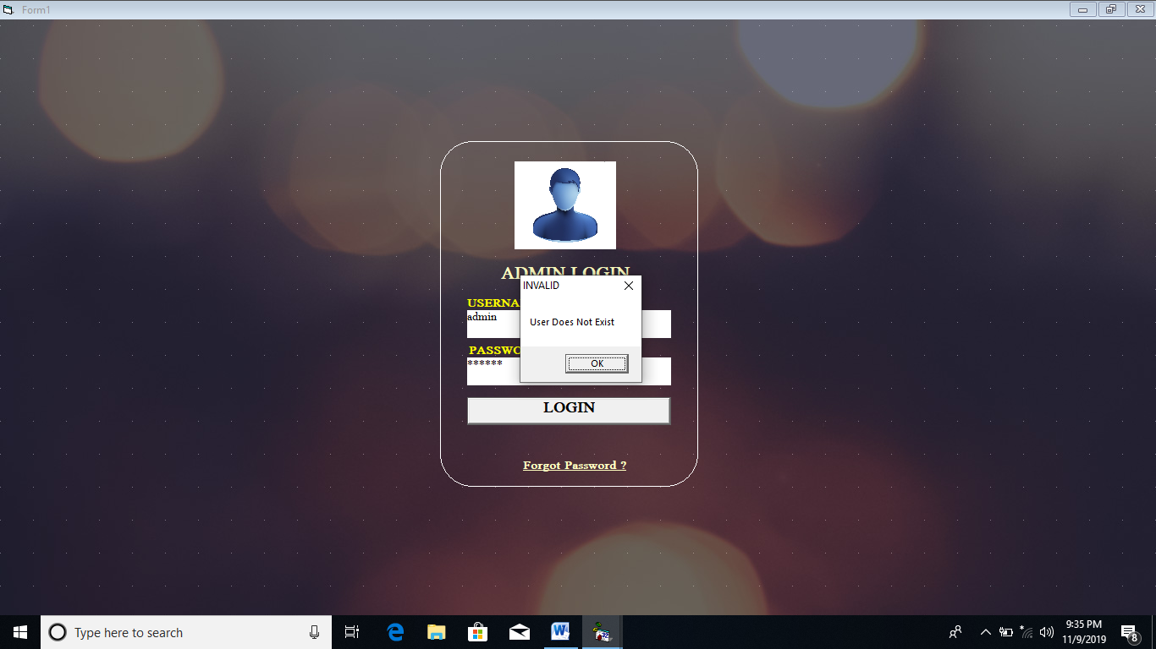

**5.1.2 CHANGE PASSWORD MODULE**

* Password Without Requirement Meet

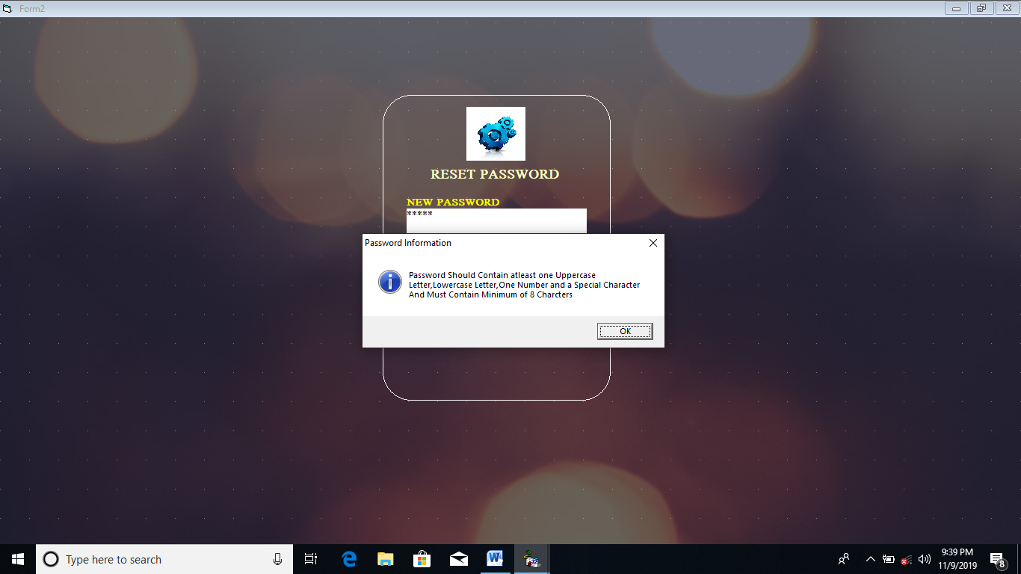

* 4Password with Requirements

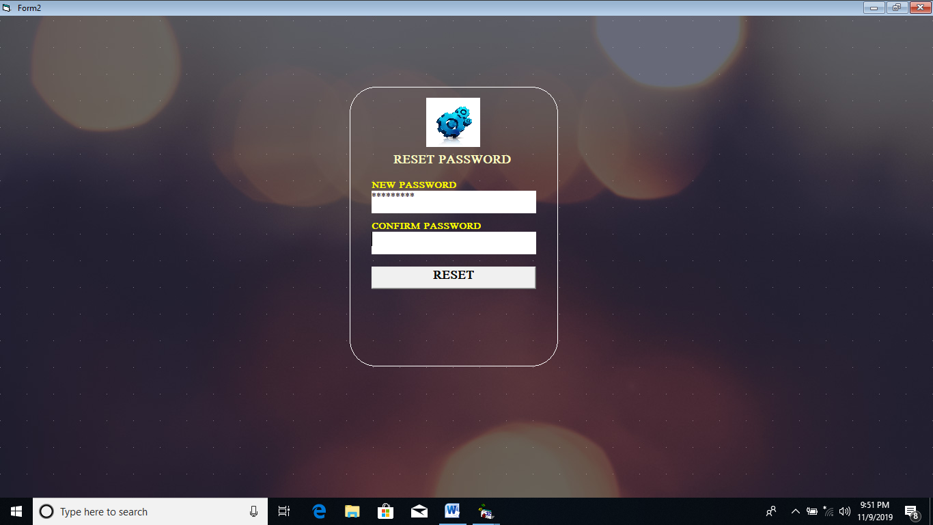

**5.1.3 MAIN APPLICATION MODULE**

* Adding Users

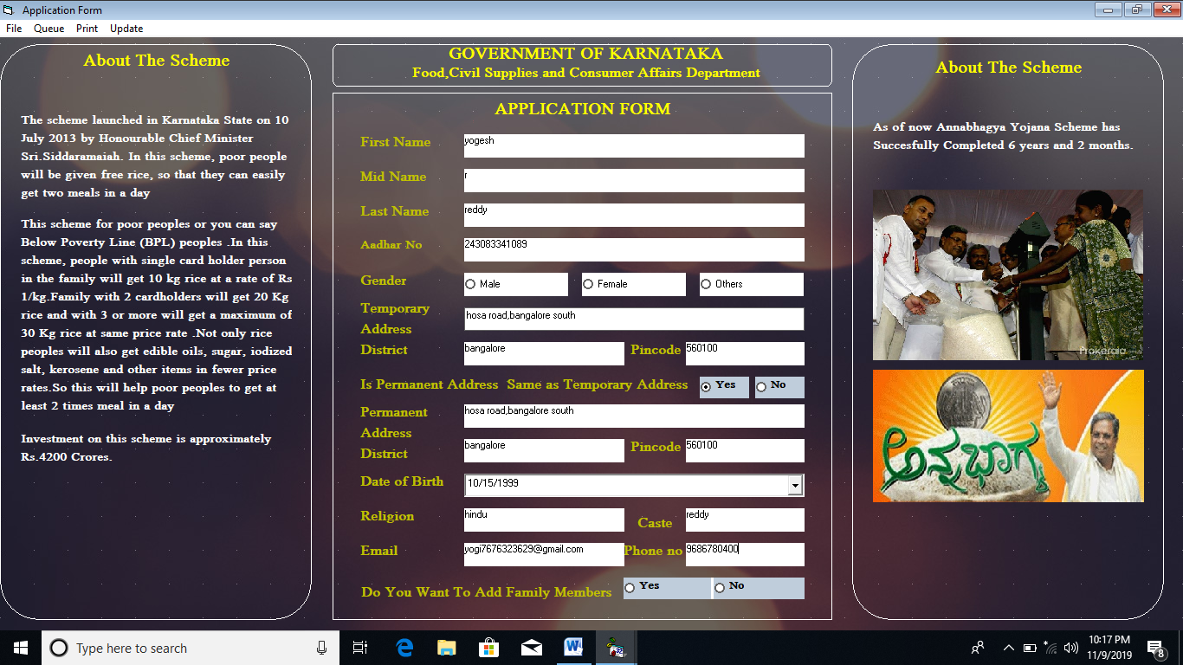

* **Adding Queue**

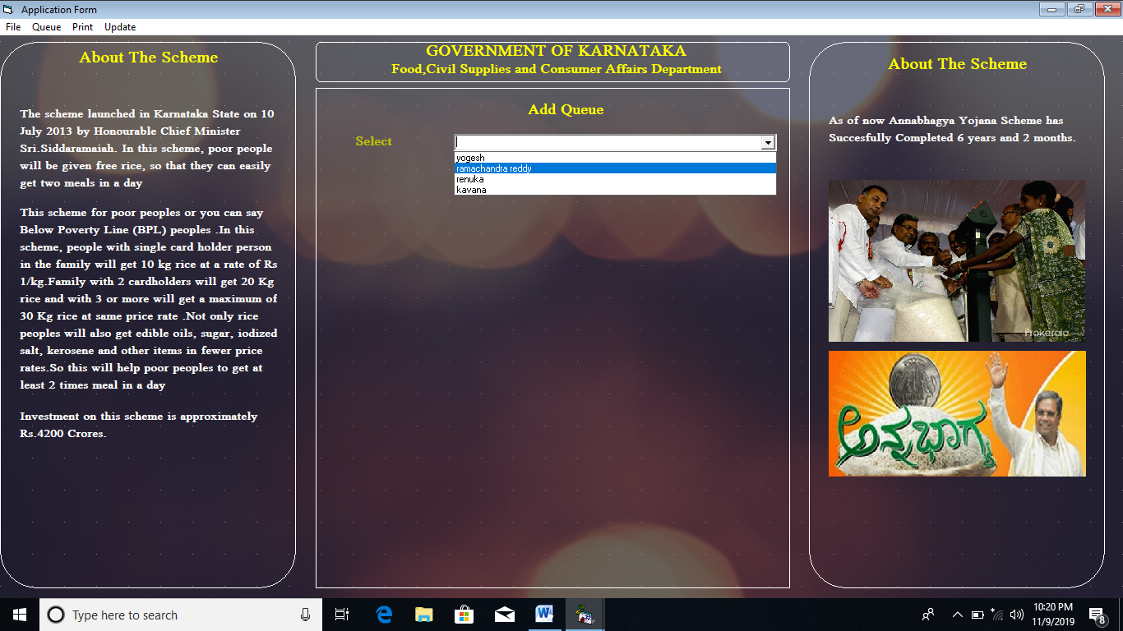

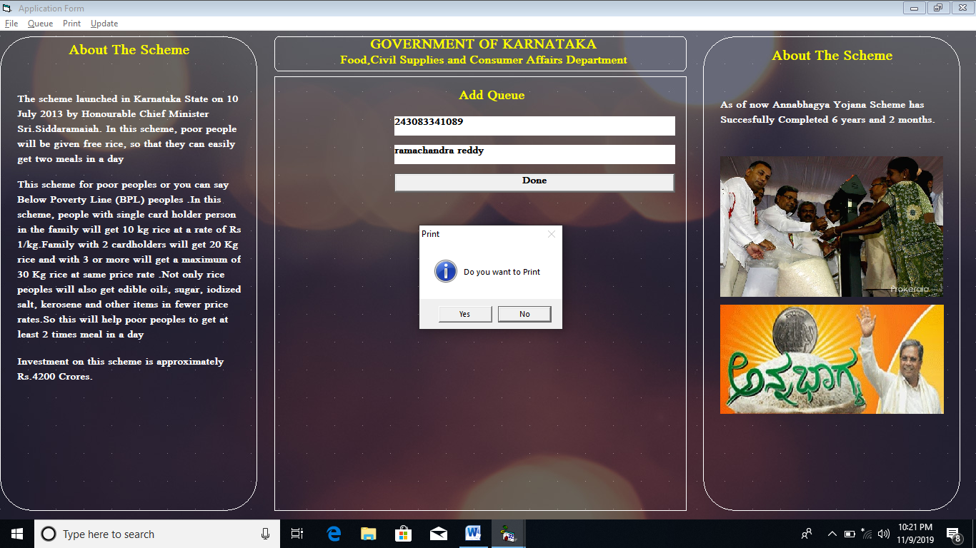

* **DATA REPORT TO PRINT TOKEN**

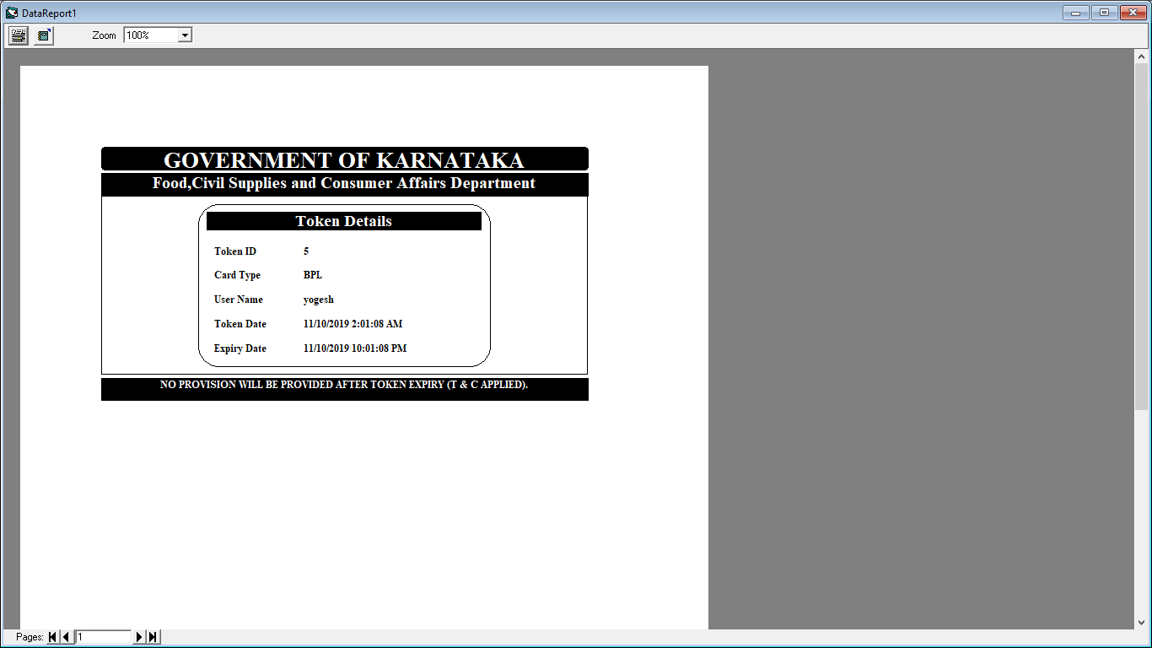

* **DATA REPORT TO PRINT CAR**

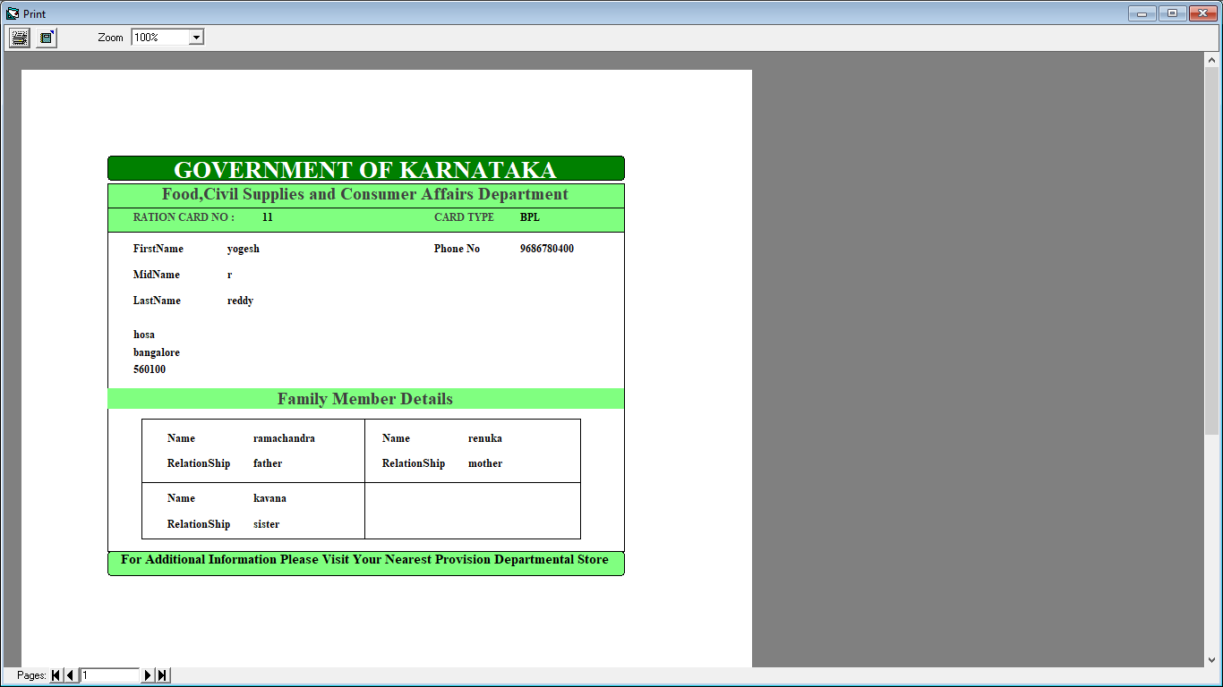

**5.2 IMPLEMENTATION MODEL**

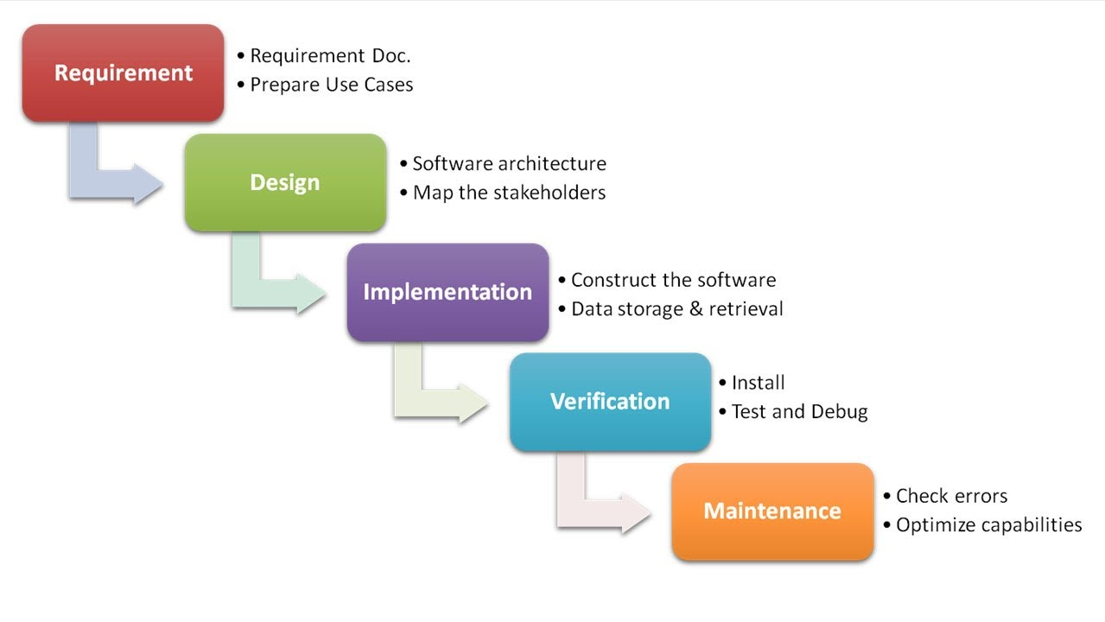

The **waterfall model** is a breakdown of project activities into linear sequential phases, where each phase depends on the deliverables of the previous one and corresponds to a specialisation of tasks. The approach is typical for certain areas of engineering design. In software development, it tends to be among the less iterative and flexible approaches, as progress flows in largely one direction ("downwards" like a waterfall) through the phases of conception, initiation, analysis, design, construction, testing, deployment and maintenance.

The waterfall development model originated in the manufacturing and construction industries; where the highly structured physical environments meant that design changes became prohibitively expensive much sooner in the development process. When first adopted for software development, there were no recognised alternatives for knowledge-based creative work.

**6.CONCLUSION**

**6.1 OBJECTIVES**

* Organizes the queue and enforces the appointments in a smoothly manner.
* Reduces queue length, as well as improves customer satisfaction.
* This application can be used in any number of shops.
* Enables faster performance thus helping the management reduce their operation cost.

**6.2 FUTURE ENHANCEMENTS**

* Internet Based enabling the user to print their own Token.
* Find out a solution for easy access to application using Android Programming.

**7.REFERENCES**

* **“Learn Visual Basic 6.0” by Lou Tylee.**